**Challenge #3**

**We have a nested object, we would like a function that you pass in the object and a key and get**

**back the value. How this is implemented is up to you.**

**Example Inputs**

**object = {“a”:{“b”:{“c”:”d”}}}**

**key = a/b/c**

**object = {“x”:{“y”:{“z”:”a”}}}**

**key = x/y/z**

**value = a**

Answer:

1) I have written python code using above challenge and below code placed in my private Github Repository

-------------------------------------------------------------------------------------------------------------------------------------.

##

**# Example Inputs**

**# object = {“a”:{“b”:{“c”:”d”}}}**

**# key = a/b/c**

**##**

**# object = {“x”:{“y”:{“z”:”a”}}}**

**# key = x/y/z**

**# value = a**

def getKey(obj: dict):

keys = list(obj)

if len(keys) != 1:

raise Exception('either multiple keys or empty dict found')

else:

return keys[0]

def getNestedValue(obj: dict, key: str, isFound = False):

# print(obj, key, isFound)

if type(obj) is not dict and not isFound:

return None

if (isFound or (key in obj.keys())) :

if type(obj[key]) is dict:

return getNestedValue(obj[key], getKey(obj[key]), True)

else:

# print(f'obj[getKey(obj)]: {obj[getKey(obj)]}')

return obj[getKey(obj)]

else:

nestedKey = getKey(obj)

return getNestedValue(obj[nestedKey], key, False)

if __name__ == '__main__':

obj = {'a': {'b': {'c': 'd'}}}

value = getNestedValue(obj, 'c')

print(value)

--------------------------------------------------------------------------------------------------------------------------------------

**Python Execution Steps**

For the above task I am using Google Cloud Platform (GCP), for executing the above task, first we have to provision the VM Instance and we have to install python and all the dependencies.

And also we have execute the code.

Created a VM instance by the name of “**vikas-python**” in region “us-central1” and machine type – “e2 medium (2vCPU, 4GB Memory)

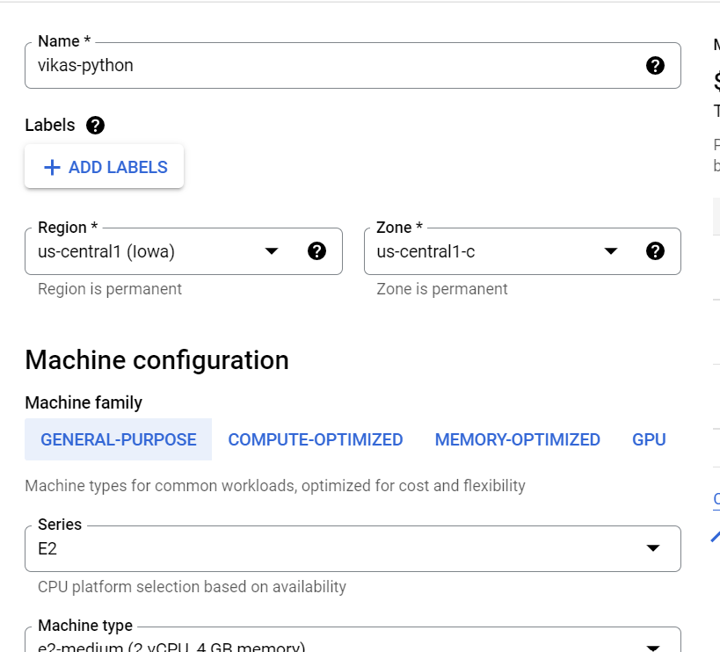

And also we have to configure image = Centos7 and with Network, and by allowing HTTP & HTTPS service as I am taking default Network. And provisioning the VM Instance.

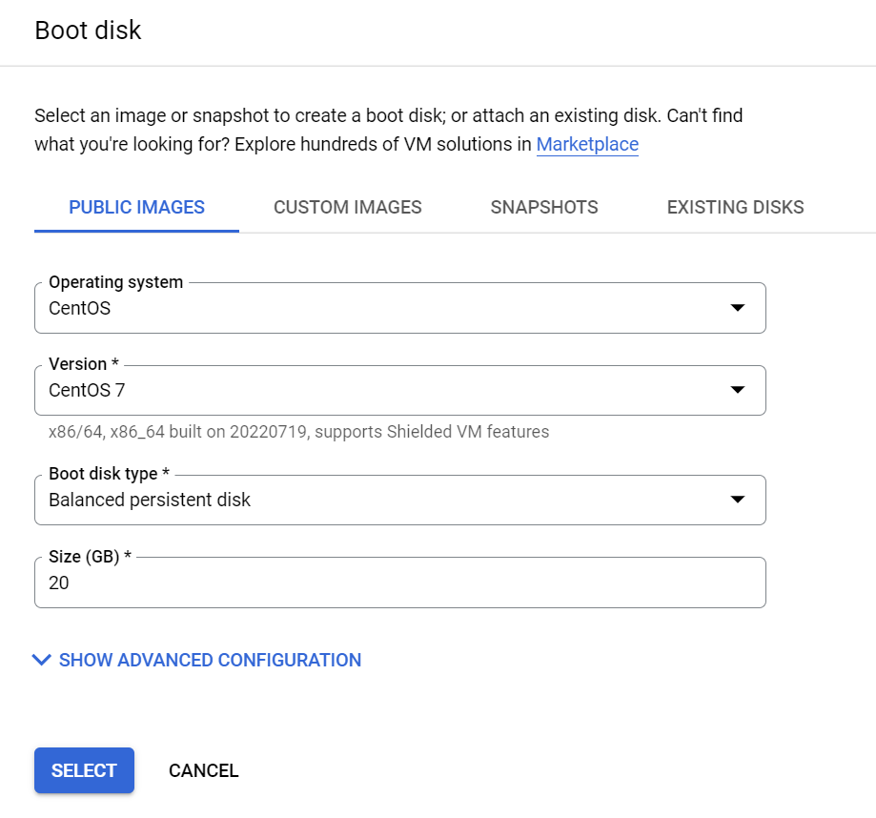

Login through SSH into the VM Instance and then install git and python with version 3.

After that clone the code and execute the code.

To install git and python: **sudo yum install update -y**

**sudo yum install git -y**

**sudo yum install python -y**

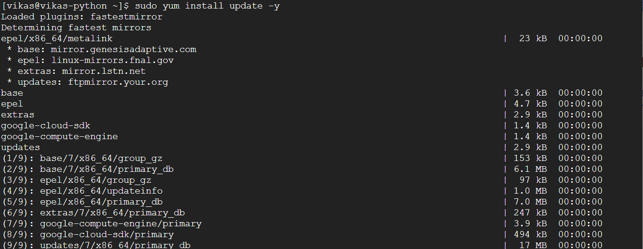

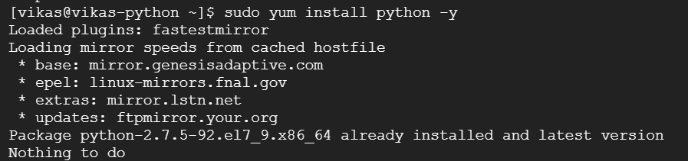

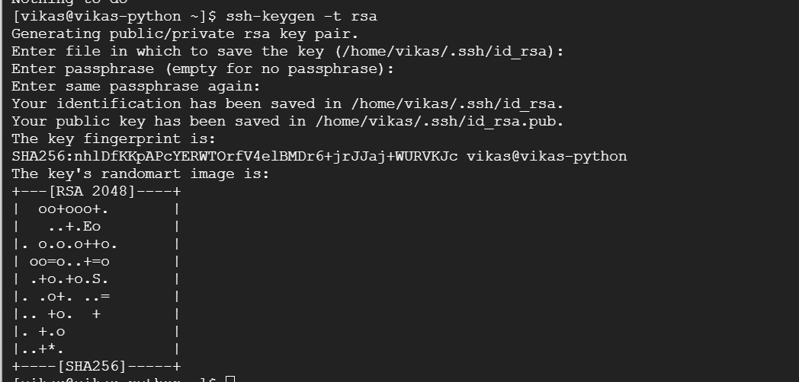

We have created an SSH KEY and copied that code into the GITHUB in SSH AND GPG KEYS for this we have to go to the settings in github. Now we can clone the code using ssh url.

And we can goto the directory in which our python file exist.and execute the code by using python in the VM Instance.

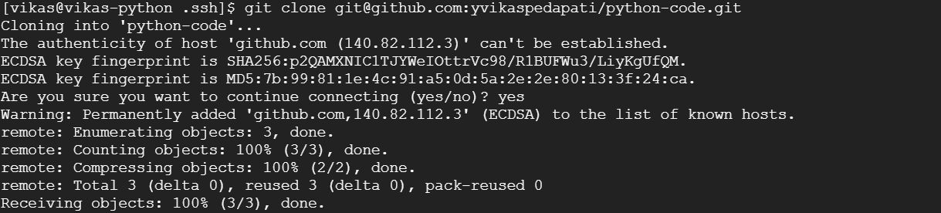

Execute the command by using = **python3 challenge3.py** -- to get the output.



Final output we have received**: d**